Lesson Facilitator: Pediatric CNE’s
Attendance: New pediatric nurses in Fraser Health
Overview/Purpose  - To review specific information related to working in pediatrics in Fraser Health.  - The information in this Regional Pediatric Orientation is information that is not covered in Acute Care Orientation, or has been altered to include pediatric specific information. |  |  | Learning Intentions/Objectives  - The learner will have additional knowledge about non nursing information that will help them with navigating their FTE, applying for lines, using the ASC system, and know where to find the resources  - To show the learner how to navigate the FH Pulse so they can find resources they need  - To have the learner be aware of what documentation is available for the pediatric population and why we have this documentation  - To give the learner the information on expectations of an appropriate admission and discharge  - The learner will have more information on pediatric specific equipment and how to use it, they will have knowledge on positions of comfort and hold techniques for a variety of tasks  - To review 3 pediatric specific Simulations that are not covered in the Fraser Health ACO
Preparation and Resources  - Prepare by reviewing the  - 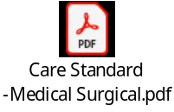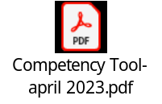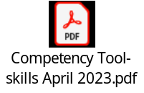  - Completion of Pediatric Foundations and PEWS LH courses  - Review agenda – sent out with pre-reading- create –built off this lesson plan  - Do we want to put in the competency checklists for here? |  |  | Standards and Policies Addressed  - Pediatric and Child and Youth Care Standards  - Pediatric Competency and Skills Tools  - Documentation  - Professional Image  - Hand Hygiene
Time | Key Concept | Content |  | Instructional Strategies
2 min | Brief description of the intent of activity | Welcome to Pediatrics in Fraser Health  “We recognize that Fraser Health provides care on the traditional, ancestral and unceded territories of the Coast Salish and Nlaka’pamux Nations, and is home to six Métis Chartered Communities  Today is to give you a brief overview of “everything pediatric” we would like you to know, as well as leave opportunities to answer questions and comments from today’s session and follow up questions from the virtual session. |  | Use of computers – intranet, FH Pulse  Lesson plans for individual sessions  Power point  In person Simulation with the SIM team
30 min | Introduction | - Community Meeting instructions-  - You were sent the agenda and pre-reading materials, what are the “hot topic” questions you have from these resources?  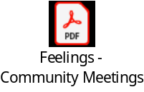 |  | Ice breaker – Community Meeting- put up a slide of “feeling words”  - How are you feeling today?  - What is your goal?  - Who can help you?  Parking lot the questions the learners have from the pre-reading and agenda, as well as the virtual presentations.
30 min | Lesson Plan – Non-Nursing Basics | In this section we are going to review areas of nursing that you need to know that don’t involve patient care  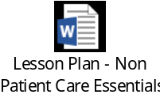 |  | 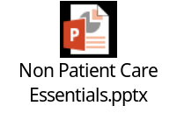
15 min | Lesson Plan FH Pulse | Login to FH Pulse and show  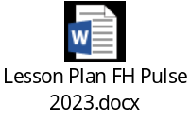 |  | Show learners the information through the FH Pulse  Intranet- laptop
15 min | Lesson Plan Documentation | Power point presentation Review PEWS guidelines, education (initial and ongoing)  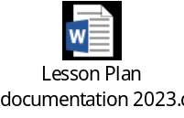
15 min | Lesson Plan Introduction to Admission and Discharge | Power point presentation  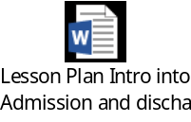 |  | 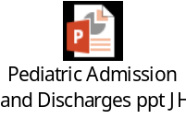
15 min | COFFEE BREAK | 15 min |  | COFFEE BREAK
90 mins | SKILLS | Peds Equipment  - Bili set up- single, double, triple  - Breast pumps-types and set up  - Taping oxygen NP’s/masks, NG tubes  - Topical Anesthetic Comparison Chart  How to Hold  - BW  - IV starts-op sites and lotion practice  - LP |  | Use lap top to look up CS and papers on WFI  
30 min | LUNCH
180 mins | Simulation | Respiratory  *Gloria to have chart prepped  Seizure  Post-op surgery- blood product administration reaction  *Sarah to have chart prepped
20 min | Questions | Individual questions at the end of each lesson plan  Simulation questions will be discussed in the debrief after each scenario and included in the SIM time
5 min | Closure | Assess learning, relate learning to practice or future lesson |  | (i.e.: post-test, etc.)
5 min | Evaluation | Paper Evaluation |  | evaluation form- complete before they leave

